Mona Vale Emergency Department

SUMMARY OF AUDITS APRIL 2013

Imaging in renal colic- Stuart O’Reilly, Tom Longworth

49 patients had CT scan M>F
Commonest indication for imaging was flank pain
On CT KUB 29 had stone disease, 20 didn’t - ?passed in 5 of these
Males: 70% +ve CT KUB
Females: 39% +ve CT KUB
5/8 patients with no haematuria had a stone
20/35 patients with haematuria had a stone
Only 13 (43%) had an x-ray KUB
- 5/13 stones visible on x-ray
- Some urologists didn’t want the plain film
80% pts with a stone referred to urology

USS performed instead of CT for ? renal colic in younger patients F>M
13/49 positive:
- 9 had stone disease
- 4 had hydronephrosis but no stone seen ?passed
- 2 went on to have CTKUB
This group of patients included those imaged for pyelonephritis

Recommendations for improvement:
- Use of ACEM renal colic guidelines (attached):

  - Low dose CTKUB is first line
  - Consider US with an x-ray KUB for pregnant, recurrent stone disease, younger patients (F>M)
  - All stones >4mm should be referred to Urology

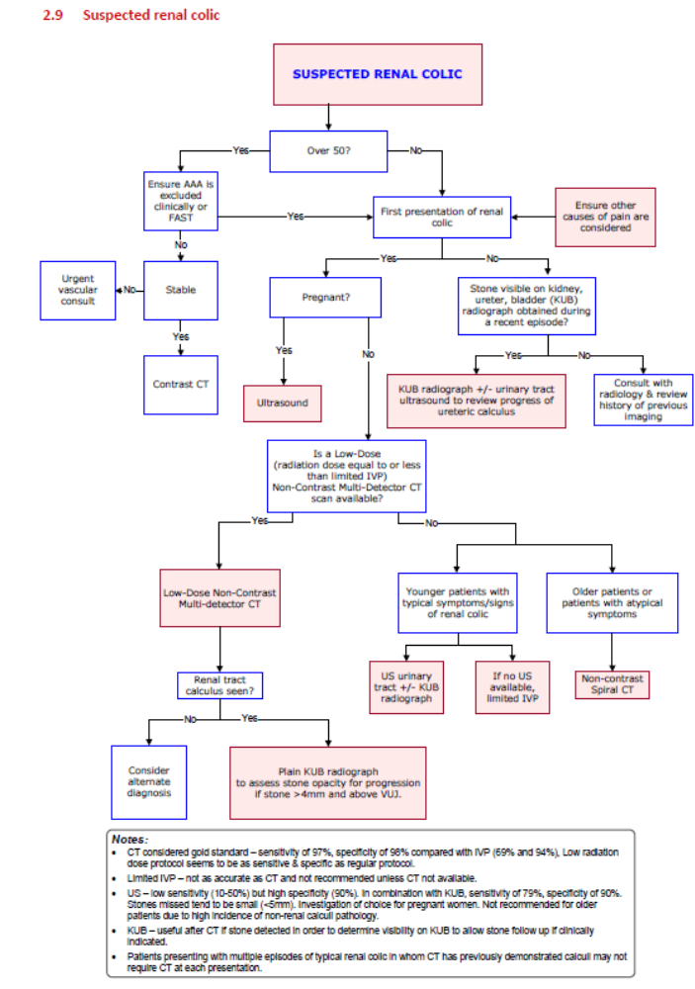

Diverticulitis- John Bryant, Andi Jones

34 patients – most common age range 76-85yrs
Blood tests in 30 – FBC elevated in 12, CRP significantly up in 15
CTA in 19/34 – 13 diverticulitis, 3 complicated, 2 normal, 1 diverticulosis
11 (32%) admitted
- 9 IV antibiotics
- 2 PO antibiotics
- No patients had surgery
Appropriate use of investigations in this patient group (should have bloods and either CTA or USS)

Recommendations for improvement:
- Use of VBG lactate recommended for all elderly patients presenting with abdominal pain
- If discharge from ED need referral for OP colonoscopy if haven’t had one before (risk of ca)
- Consider use of APAC for IV antibiotics if acute uncomplicated diverticulitis, (pathway for above presented).

ICU admissions- Joe Ellston, Oli Carson

44 patients admitted to ICU from ED
Average time to referral to ICU 4.03 hrs
Average time from referral to seen by ICU 2.11 hrs
Average length of stay in ED 7.15 hrs
Most common diagnoses: sepsis, overdose, CAL, DKA
Interventions: 28 nil, 5NIV, 10 art lines, 6 CVC
Who sees the patient in ED? 30 seen first by ICU SRMO, 6 seen first by ICU VMO, (7 not documented)

Conclusions:
- Appropriate patient referral
- Why no interventions in 28/44, (spent a long time in department)
- Average time in department 7.15hrs – very resource demanding for medical & nursing staff

Recommendations for improvement:
- We should aim to speed up referral to ICU (often this is predictable)
- Refer first to VMO and let SRMO know as they can come and help with lines etc.
- Need to improve documentation of times referred etc.

