BAT phone at 6.30am
76y old female with acute onset shortness of breath
RR 40, sats 80% r/a, HR 140, BP 220/100, GCS 15
ETA 5 mins

How would you prepare for the arrival of this patient?

What are your immediate management priorities when the patient arrives?

What Investigations would be useful in this patient?

ECG shows
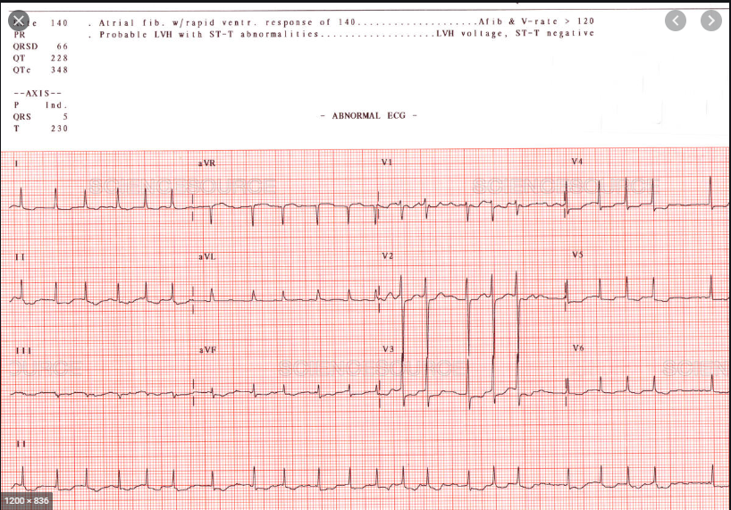

The nursing staff ask if you would like 40mg IV Lasix?
The patient is sweaty and agitated. The other SRMO you are working with suggests 5mg morphine. What do you think?

